Q1) Create the tables Member, Books, and Issue WITHOUT constraints.
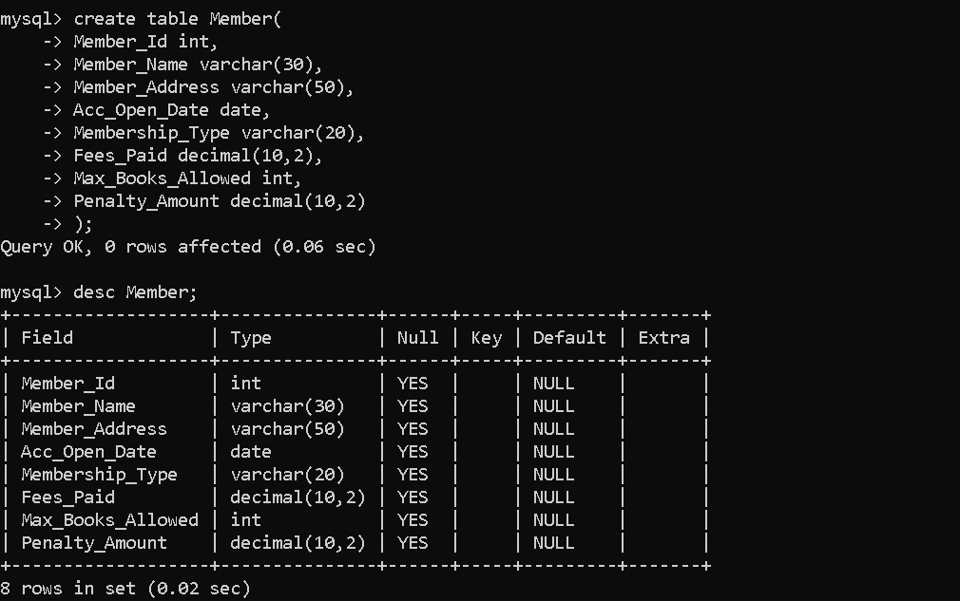
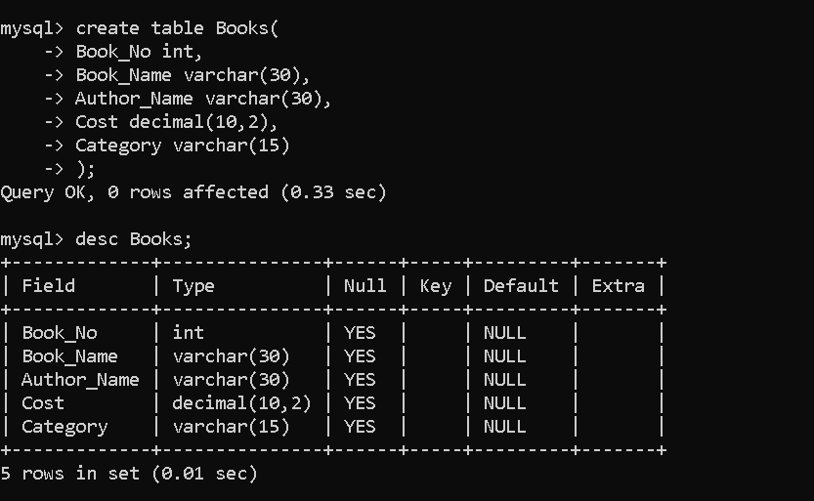
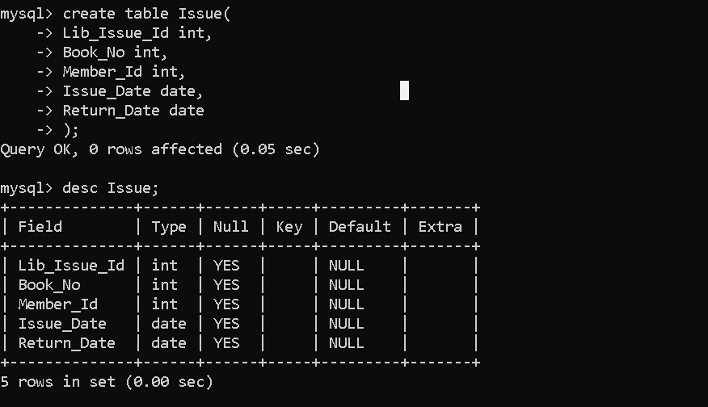
Q3) Drop the Member table.

Q4) Create the Member table again with these constraints:
- Member_Id must be PRIMARY KEY
- Membership_Type must allow only:
('Lifetime','Annual','Half Yearly','Quarterly')
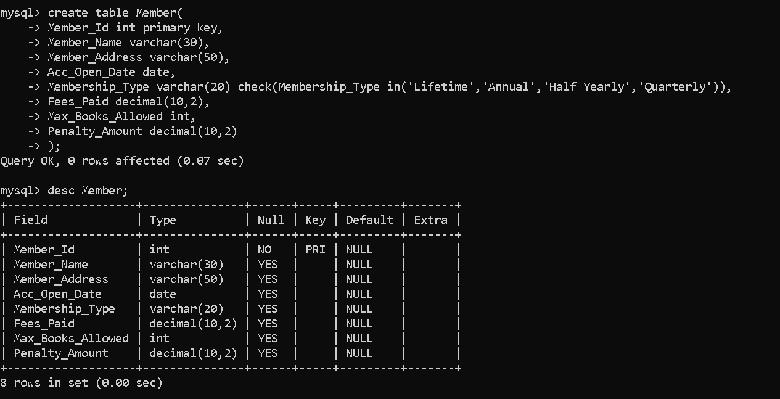

Q5) Alter Member table to increase Member_Name size from 30 to 40.

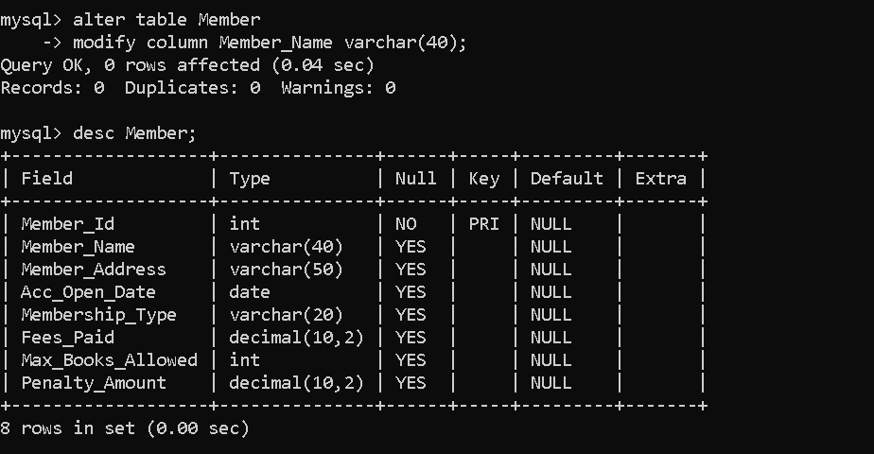
Q6) Add a column Reference (VARCHAR (30)) to Issue table.
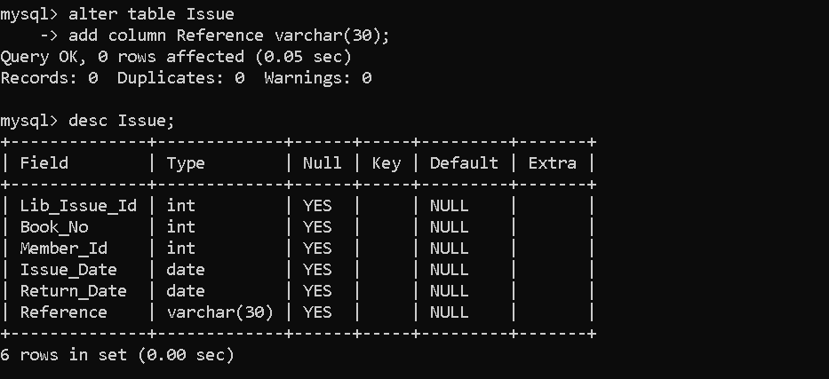
Q7) Drop the column Reference from Issue table.
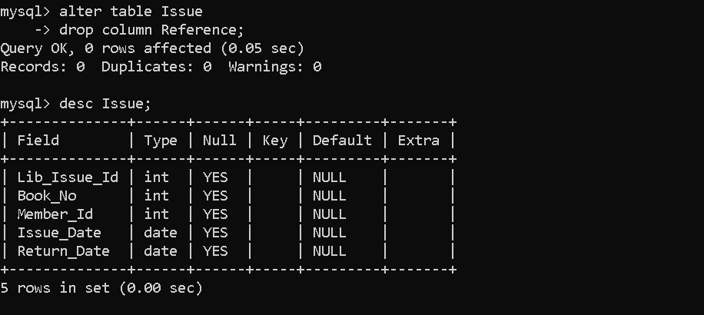

Q8) Rename the table Issue to Lib_Issue.
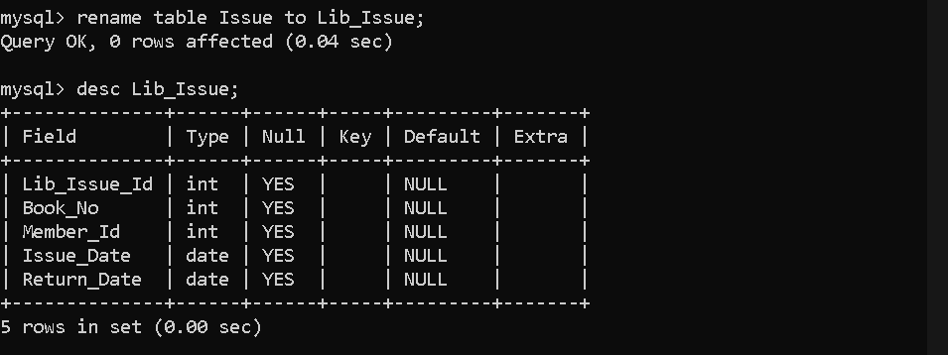
Q9) Insert the following records into Member table:
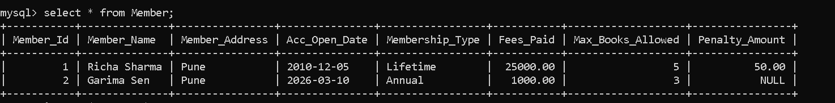
Q10) Insert at least 5 more records with suitable data into Member table.
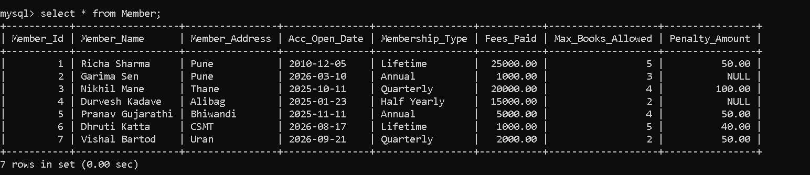
Q11) Try to decrease Member_Name size from 40 to 20.
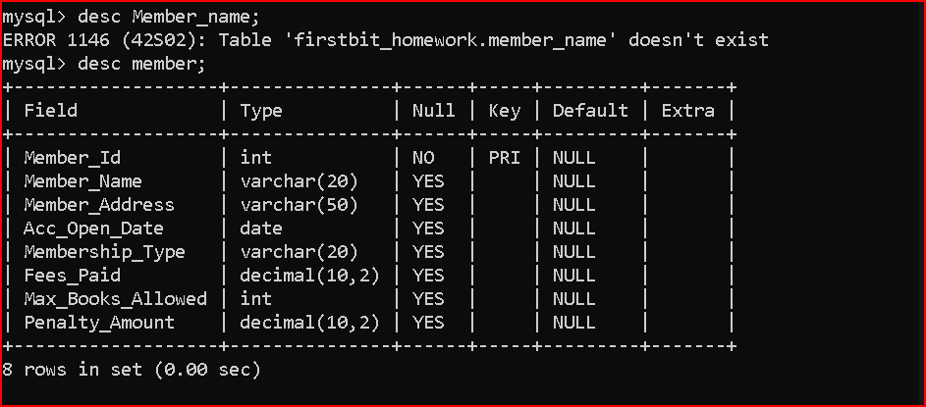
Q12) Add a CHECK constraint:
Max_Books_Allowed must be less than 100.

Q13) Create a backup table named MemberBackup using the Member table.
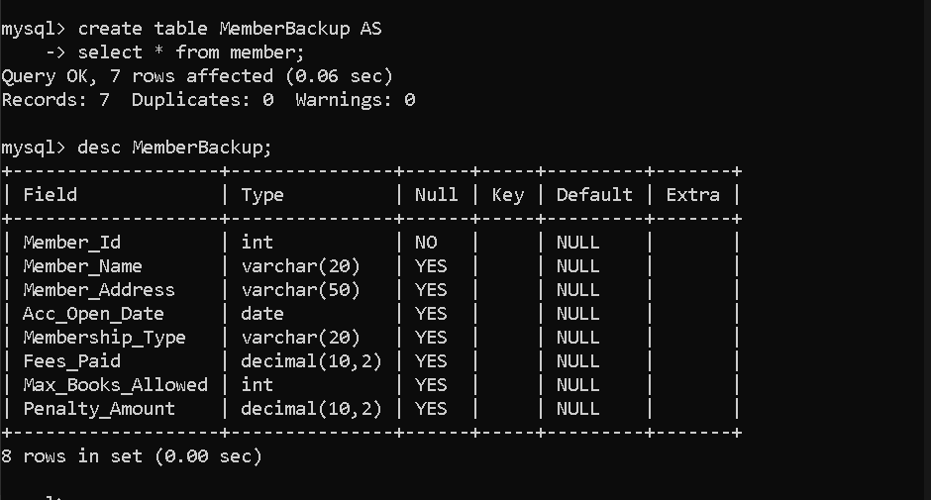
Q14) Add named constraints:
- Max_Books_Allowed < 100
- Penalty_Amount <= 1000
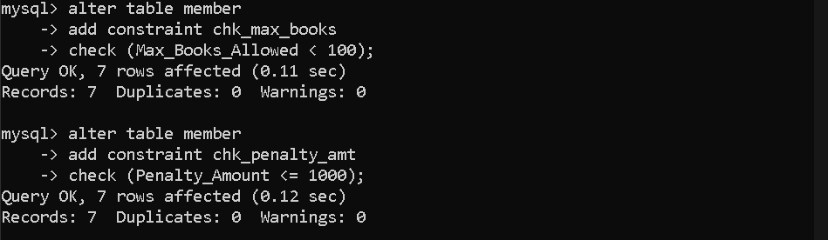
Q15) Drop the Books table.
Q16) Create Books table again with constraints:

